***Skill – Design Patterns and Principles***

**Exercise 2: Implementing the Factory Method Pattern**

**Purpose:- The Factory Method Pattern provides a way to delegate the instantiation of objects to subclasses. It helps in creating objects without tightly coupling the code to specific classes.**

**CODE:-**

**Document.java:**

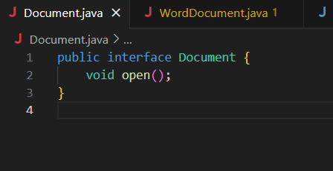

**PdfDocument.java:**

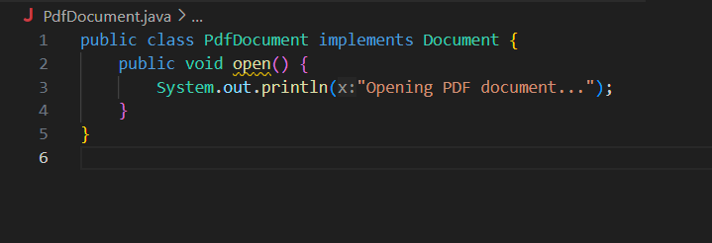

**WordDocument.java:**

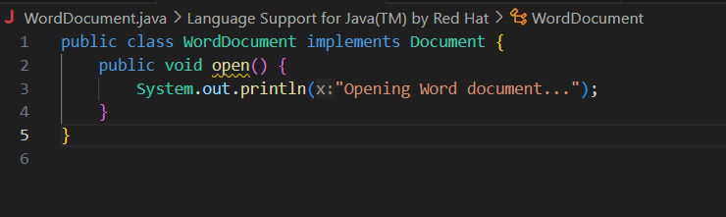

**ExcelDocument.java:**

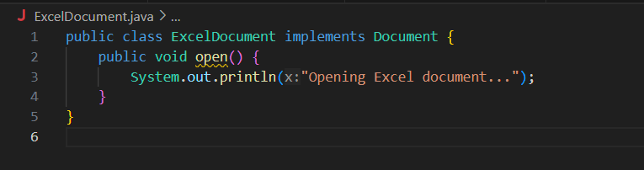

**DocumentFactory.java:**

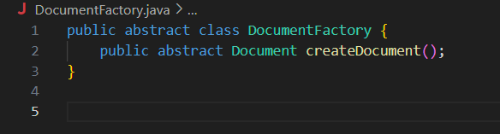

**PdfDocumentFactory.java:**

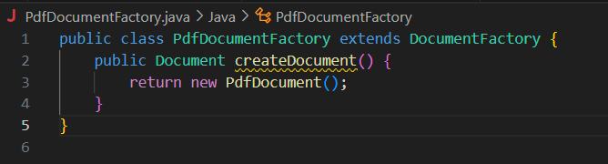

**WordDocumentFactory.java:**

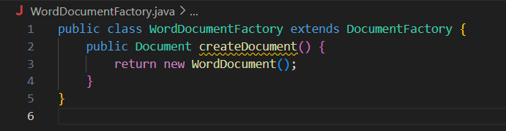

**ExcelDocumentFactory.java:**

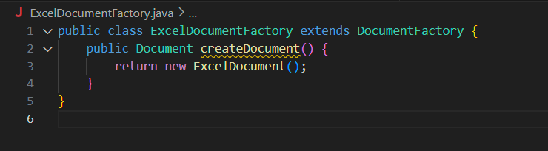

**Main.java:**

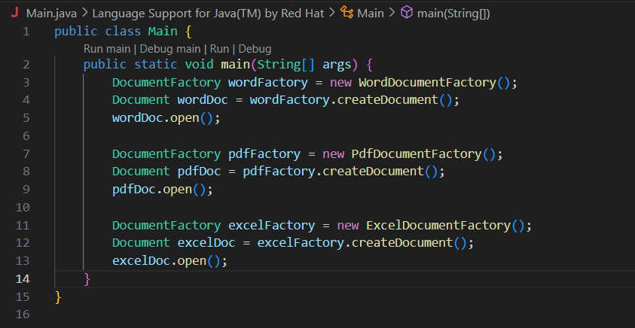

**Output:**

